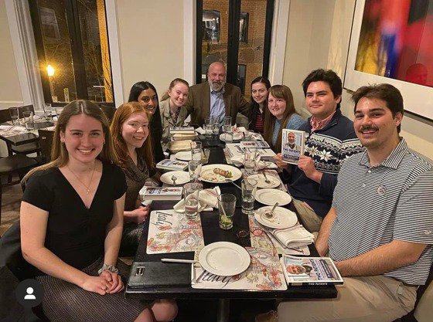
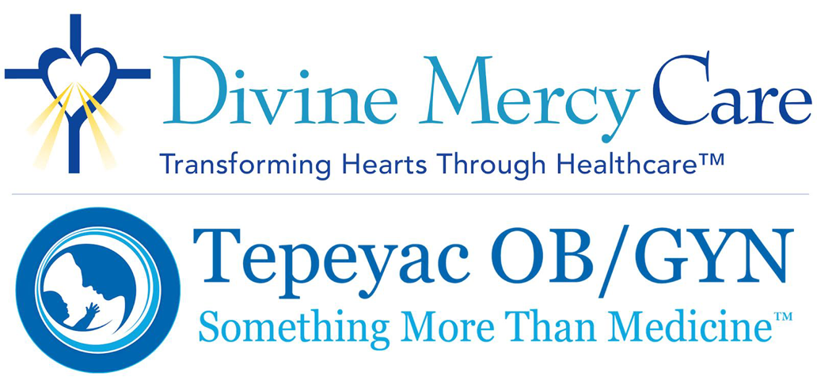
March 2023 Newsletter

Lent, 2023
Dear Friends:
Since the beginning of this year, and with acceleration since the beginning of Lent, I have met with medical and nursing students across the country. They have invited Divine Mercy Care to share the story of Tepeyac OB/GYN. We have found each other because we have openly and successfully resisted the “abortion-on-demand” totalitarian culture of our medical specialty WHILE providing excellent women’s health — from fertility-awareness-based-methods to partnering with regional pregnancy centers, to providing real alternatives to the abortion position for sick, “incompatible with life” children in the womb. These are real signs of hope for so many of the courageous next generation of providers and physicians who will not compromise on their life affirming values.
The Mother on those hills of almost four decades ago, of Tepeyac and Crizevac, said people would be healed and cared for when they came to Tepeyac. Do not fear any illness, vexation, anxiety or pain she encouraged, as she pointed to the Way of Medicine as Mercy, her Son. For three decades, we have refused to join the progressive ideology that abortion is “health care” and the “solution” of quickly ending the life of a very sick child as if that child was only identified by their illness. You have enabled us to practice medicine and teach others this alternative to the abortion dominated cultural medical narrative.
Your trust and support of Divine Mercy Care has enabled us to encourage and inspire and exhort others to struggle against abortion on demand and take a hard look at what excellent women’s health care can be. This struggle is traumatic for them and for me. I have been dealing with PTSD during this time, but through the lens of forgiveness and mercy, not shame and alienation. Back in those two critical years of performing abortions, I did suffer because of the brutality and the reality of what I was doing with my hands, my head and my heart. Hardness of heart because of the abortion violence to the least of our human family was taking my heart to the hardness of a diamond. His mercy, my parent’s prayer and another life affirming doctor’s witness helped me experience the love and mercy of Christ. Now my PTSD is only one of sadness to constantly discern in silence and conversation how can we at Divine Mercy Care share this joy, this peace that surpasses all understanding?
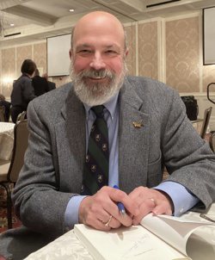
As we enter the upcoming final week of Lent, I reflect on this: “Those who have no sin may throw the first stone.” While sitting with this line from scripture, Jesus speaks to the Elders who caught a woman in adultery. On Good Friday we will hear: “Father forgive them for they know not what they do.” This is the challenge of my own cognitive dissonance I wrote about in Two Patients. We must always examine ourselves rather than demonize or judge others. Jesus will use this in a positive, healing way towards our own woundedness, our own damaged self, if we let Him, seek Him, ask Him to give us the grace to forgive the people in our lives who hurt us. Forgiveness is at the heart of the reality that health is based on gratuitous, sacrificial relationships. There is no other way to live Easter without the cross and those cries from the cross from Jesus to each of us. That is my prayer for Lent for all of the Divine Mercy Care and Tepeyac family. Take these words to heart, it is the secret for allowing His Divine Mercy to transform our hearts.

Click Here to Donate to DMC

AVAILABLE NOW:
Divine Mercy Care 2022 Annual Report
We are so grateful for our donors who helped provide financial aid to more than 400 women in need this past year. Your contributions make a real difference in the lives of families in our community. We look forward to continuing to change hearts through healthcare! Thank you for your continued support for life-affirming medicine!
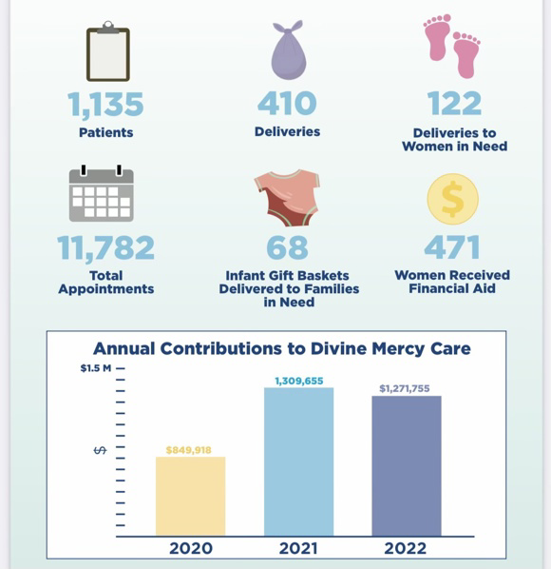

Thank you Saint Timothy’s Catholic School!
This month, Barbara Remington spoke to the 7th grade religion classes at Saint Timothy’s Catholic School in Chantilly VA, educating the children on the various stages of human development of unborn babies, from 7 weeks to 26 weeks. The students were able to hold and touch life-like models of unborn babies to help help them better appreciate the value of all human life. The students also hosted a beautiful and fun baby shower in honor of our many mothers in need at Tepeyac OB/GYN. Thanks especially to all the room mothers, staff and parents at Saint Timothy’s, especially Mr. Pryor, the school principal, for their kindness and support.
If you would like to schedule Divine Mercy Care to speak at your school, please contact us at info@divinemercycare.org

