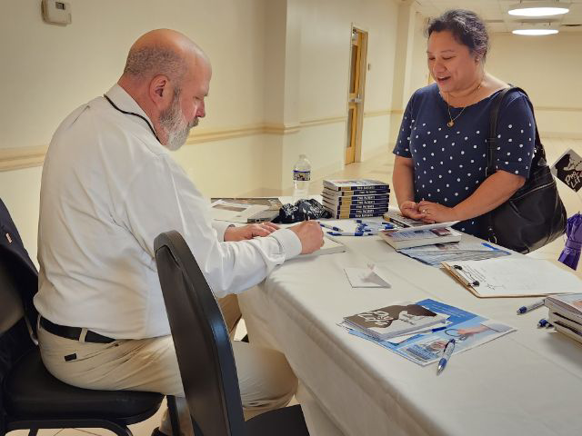
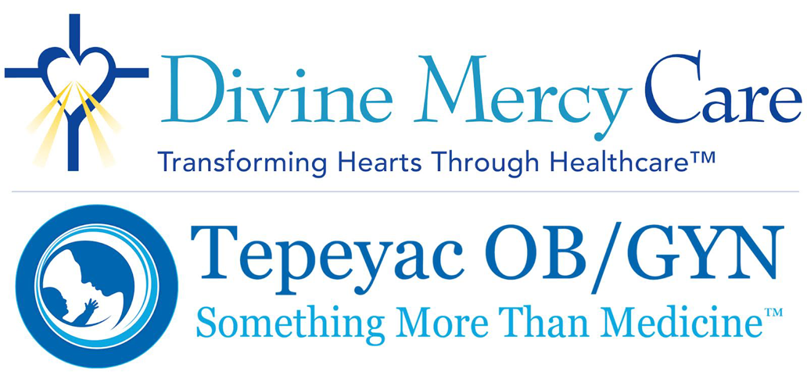
May 2023 Newsletter
Dear Friends:
May is the month of May flowers and May crownings. Work. Nature. The Madonna. These things have kept me busy this month. I began the month with an interview with the Jesuit, America magazine. The idea of medicine that is both life affirming for the Gospel of Life and recognizes the levels of social justice is attractive to more than conservative traditional folks. We are so broken, and the only way to build a culture of life is to speak to those who may not initially see the value or the focus of our work at Tepeyac.
I participated in a wonderful event and book signing at Nativity Catholic Church this month and St. John’s in Leesburg hosted a wonderful 5K walk/run fundraiser on behalf of Tepeyac. I am SO grateful!
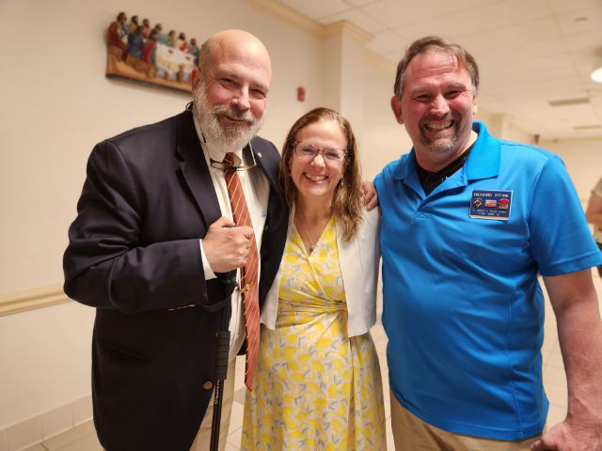
I’ve been speaking with thought leaders this month about the coming attack of being a “fake” medical clinic by the “death dealing” clinics that dominate our public discourse. I’ve also been doing a lot of thinking and writing about what practicing medicine as mercy looks like where the rubber meets the road — collaboration with pregnancy centers, fertility awareness, and conundrums such as embryo adoption.
House calls brought me to Dr. Bill McCarthy who had pancreatic cancer return with a vengeance as he cares for his wife, Mary Lynn, in Covington, Kentucky. He was the family practice guy who allowed Carolyn and I to use his office during 1994 as a jump off for Tepeyac Family Center. Another trip to New Jersey took us to Joe and Ronnie and their difficulties with heart attacks and chronic pain issues. These friends were so influential helping me discern my future after coming off the hill in Medjugorje in 1989…so much suffering by so many close friends.
I was able to fish with my son and my wife this month on the Chesapeake and in the Catskills. Fishing has always been a time of recollection, renewal and retreat for us, and we had a visit with the cloistered nuns of the Monastery of Our Lady of Beatitude in Livingston, Manor, New York. I wrote small parts of Two Patients there and it has prepared us again for the work ahead by orienting us in gratitude for all the people who have made this work a success for the last three decades.
What has consumed me most this May has been laying the foundations both through the principles and the structure of what passing on the wisdom we’ve learned at Tepeyac onto the next generation will look like — teaching others to fish. We will not duplicate other efforts but use the medicine as mercy relationship model to assist the next generation of doctors, nurses and other providers in their medical journey. Stay tuned!
Thank you Lord and our Mother for teaching us the process and path of medicine as mercy. Thank you, also, to the mothers who gave us life. You are the heart of your families and the heart of Tepeyac!
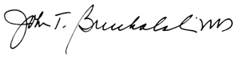

Click Here to Donate to DMC
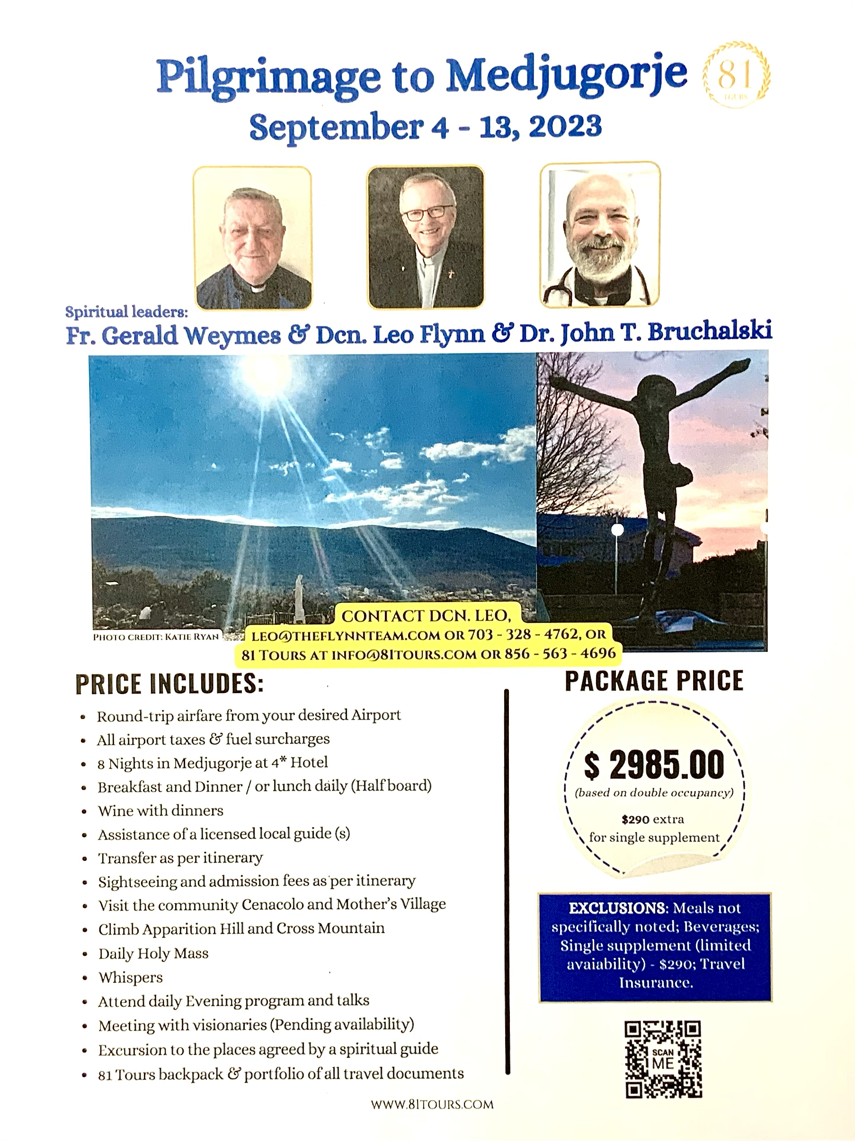

Click Here to Donate to DMC

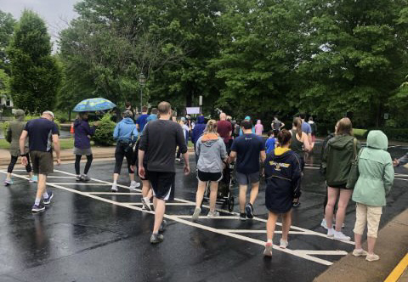
Special Thanks to St. John the Apostle Catholic Church for Raising Funds to Support Tepeyac OB/GYN
We are so grateful to St. John the Apostle Catholic Church in Leesburg for raising $2300 in a Fun Run/Walk fundraiser for Divine Mercy Care and Tepeyac Family Center on Saturday, May 13. Even with rainy weather, 125 participants came out to support our pro-life work and the care of moms-in-need. Special thanks to Alejandra Dove, Kathleen Zolbe and Mary Shea for making this event a huge success!
