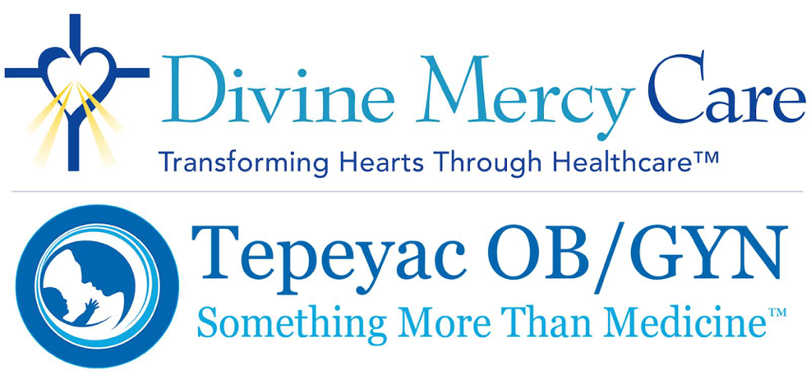
June 2023 Newsletter
Dear Friends:
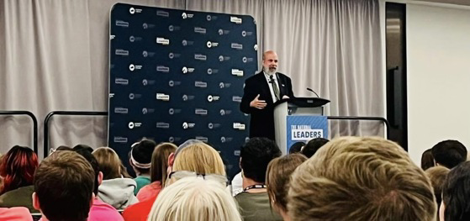
Before June ends, I want to take the opportunity to say Happy Father’s Day! Fatherhood is one of the greatly undervalued roles in society today. So many deny the importance of fathers in the lives of their children and disparage the masculine responsibilities of the father as the protector and the provider for his family. I want to thank you fathers for giving the gift of life, for being steadfast in your commitment to your families, and for supporting the women and babies who we have come through our doors at Tepeyac OB/GYN for care for almost 30 years.
Devaluing fatherhood is, of course, part and parcel of our culture’s commitment to abortion, and this month we also marked the one year anniversary of the U.S. Supreme Court’s overturning of Roe v. Wade. We are SO VERY GRATEFUL for this decision and I was pleased to mark the anniversary with an address at the Students for Life Leadership Collective last weekend. So inspiring to see so many young people there — it gives me a great deal of hope for the future!
Overturning abortion as the law of the land has provided many opportunities to change hearts and engage in conversations about the dignity of human life. While the results of those conversations and debates over the last 12 months haven’t always been satisfying, and as many pro-abortion organizations and the media have dug in their heels and spread lies about the necessity of abortion, I still embrace those opportunities to persuade.
Destruction is easy. Building is hard. Criticism is easy. Teaching is hard. Abortion is the “destruction” that ripples outward from “two patients” to families, communities and our culture. Abortion protectors like the American College of OBGYNs (ACOG) provide the heavy handed, deceitful and marginalizing criticism of those who disagree with their political belief that abortion is liberating and essential women’s health care. Destruction and criticism under the guise of choice, health and rights is also a fast way to raise money. Simply put, negativity sells, stifles and kills — which is why so many people, in the culture and in medicine — have chosen the route of using emotional manipulation rather than truth in promoting abortion as good medicine.
Along with you, Divine Mercy Care and Tepeyac OB/GYN stand with the truth.
It would be easy to lob grenades at medicine gone mad with anti-science principles from politically changing the embryological definition of when human life begins to claiming that sex is simply “assigned” at birth. A century ago, bad eugenic ideas were smoldering and beginning to build this wildfire among physicians. Those ideas of the privileged elite eventually infected students and doctors and nurses, as well as the patients they served – ordinary faith-filled believers in community and in the medical profession. The problems are legion. But focusing on those who perpetuate these ideas does nothing to stop their spread.
People who are hurting inside hurt others.
Teachers who received bad information, give out bad information.
This is the crux of why medicine has lost patient trust and in chaos today.
Divine Mercy Care and Tepeyac are making our mark in this post-Dobbs landscape of confusion and turmoil. When Carolyn and I founded Tepeyac Family Center, just about three decades ago now, we knew that God was calling us to more than practicing life affirming medicine. I understood Him to say we would help to “transform hearts through health care.” He was calling us to serve generations of patients, students, practitioners, pastors and physicians. He was calling us to witness the truth that there is a “higher Power” — and we are not it! Our practice became a cadre of men and women committed to receiving the full healing of the Catholic medical bioethics and social teaching and passing it onto the bodies and souls in their care, and then pass the lessons learned onward.
In my time since leaving the exam room at Tepeyac, this has been my mission — to tell the story of two patients and to share the truth of life-affirming medicine. It has been an incredible year of opportunity for me. I am especially inspired by the young people who aspire to practice medicine in our post-Roe world. They are hungry for guidance and the truth. I believe that, post-Dobbs, the most important work Divine Mercy Care and Tepeyac can do is to BOTH serve our patients in our local region/community AND begin to accompany medical and nursing students and peers during these times of chaos. By continuing to accompany patients at Tepeyac we are witnesses to life-affirming medicine in practice and helping families to become whole, and holy. By accompanying practitioners we will also help the tens of thousands of people they will, in turn, serve in their lifetimes.
As I have said before, Divine Mercy Care and Tepeyac OBGYN were made for this time. No one is better positioned to shape the future of pro-life medicine than we are. With your help and God’s grace that is what we will do. Thank you for your faithful support as we continue to do this difficult but incredibly important work — together.

Click Here to Donate to DMC
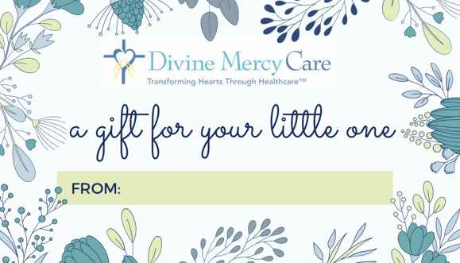
Divine Mercy Care prepares infant gift baskets for families in need who deliver their babies with Tepeyac OB/GYN.
Our goal is to prepare 125 baskets in 2023.
Would you consider a $200 donation to cover the cost of one infant gift basket? We will personalize it with a gift tag including your name/message.
In addition to monetary donations, Divine Mercy Care welcomes donations of homemade blankets and new baby items for our baby gift basket program.
Thank you for your generous support of life-affirming medicine!
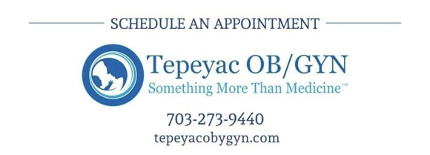
Click Here for a Wish List of Baby Basket Items

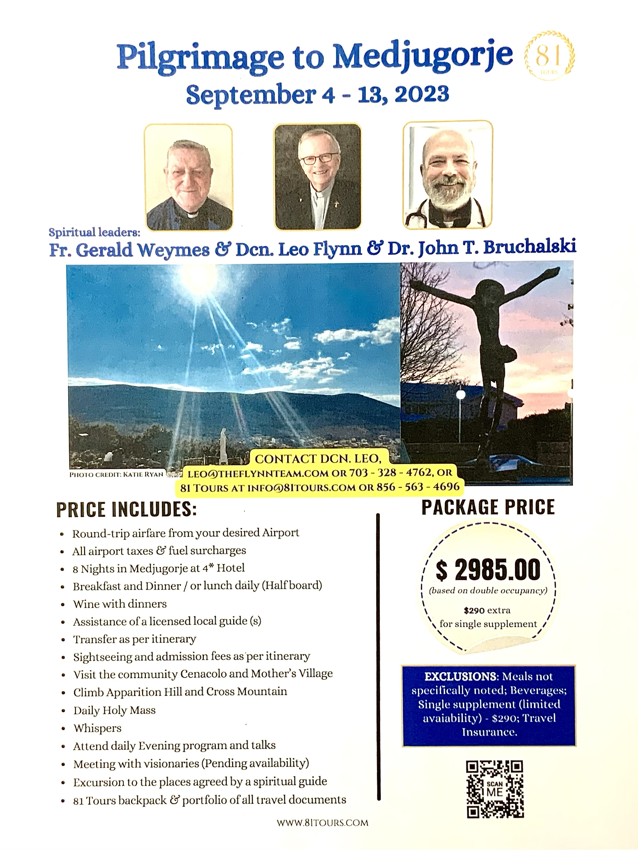

Click Here to Donate to DMC

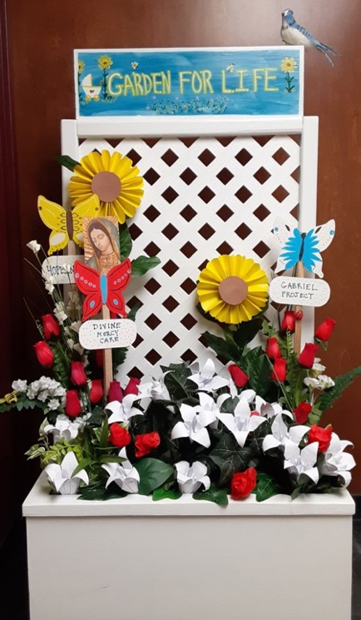
Thank You St. Veronica’s
Special thanks to Saint Veronica’s Catholic Church for supporting Tepeyac OB/GYN with its annual Garden for Life program! The effort raised more than $3000, including matching gifts from the Knights of Columbus. Thanks especially to our DMC Ambassador Shannon Branly for her efforts to organize this fundraiser for women in need. We are so very grateful for your support!

